Analysis of good practices of intervention and prevention of child sexual abuse

To provide support and protection to a child victim of abuse may be difficult in our country because of problems related to the legal interview of the child. At the moment there are no conditions in Moldova for carrying out a legal interview, particularly, there is no legislative framework regulating the interviewing process of minors victims of abuse, legal consultants are not trained to work with children; part-time specialists (teachers, psychologists) even if they do participate in the interview, most of the times their participation is formal; the state is not paying enough attention to their training in accompanying children victims of abuse during criminal procedures.
Given the above mentioned facts, we consider as good practices the results of the activities carried out for the purpose of organizing child interviews in safe conditions.

In order to contribute to the establishment of a system of legal interviewing in protective conditions, NCCAP (National Center for Child Abuse Prevention) carried out the following:

1/ Analysis of national and international legislation to determine the current advantages and flaws of provisions regarding the organization of legal interviewing of children in protective conditions.
2/ Informing and changing the attitude of specialists regarding legal interviewing procedures.
3/ Building capacities of specialists participating in legal interviews of children (criminal investigation officers, prosecutors, judges, teachers, psychologists).
4/ Providing informational and methodological support for organization of legal interviews of children victims of abuse.
5/ Strengthening the role of the psychologist within the criminal procedure.

THE FOLLOWING ACTIONS WERE UNDERTAKEN AND THE FOLLOWING RESULTS WERE OBTAINED:

1) The study “The Interview of the child victim of abuse as part of criminal proceedings” (2007) within the project „Childhood without violence – for a better child protection system in Eastern Europe”, with assistance from Nobody Children Foundation (Poland) and OAK Foundation, revealed that, often, the rights of the child victim or witness in a criminal lawsuit are violated or are ignored, despite various documents guaranteeing these rights. It was discovered that, the legislation does not provide for special training or specialization of legal consultants, teachers for participating in the legal interview with a child and accompanying a child during criminal proceeding. The role of psychologists is underestimated. At best, they are invited as a „specialists” during the trial, but their participation is merely formal.

2) Information and change of attitude was achieved by means of the campaign “Mr. Judge, I am scared” (2008). As a result of this campaign, as well as other advocacy events the National action plan on prevention and combating violence against children for 2009-2011 provides for the Establishment and equipment within court buildings of special rooms for child interviewing. The Superior Council of Magistrates and the Ministry of Justice are responsible for this task.
This step is planned to be carried out within the period between 2009 and 2011. And despite the fact that that at the moment there is no special room equipped for interviewing of children in any court building, or police or prosecutor’s office yet in the country, this task is already set as a priority in the work of state organizations.
3) For the purpose of preventing and overcoming the problem of child abuse, consolidating the actions of local administration and specialists, a series of national trainings were carried out.
The activities of NCCAP related to the training of specialists of state and law enforcement structures to work with minors must be mentioned. Thus, in 2007-2009 together with the National Institute of Justice, with support from Nobody Children Foundation/OAK Foundation, as well as support from ABA Roli, trainings for judges, prosecutors, criminal investigation officers and teachers were carried out , attended by: 22 prosecutors, 19 police officers, 9 teachers, 10 social workers, psychologists, specialists in child rights protection. The Guidelines for Professionals in Child Interviewing were developed and disseminated. As a result of the trainings, attended by specialists responsible for creation of conditions for full and safe development of children, their participation in discovering of cases of child abuse increased and they started seeking professional advice more often, especially from the Center for Psychological and Social Assistance of Child and Family „Amicul” (figure 1, 2).
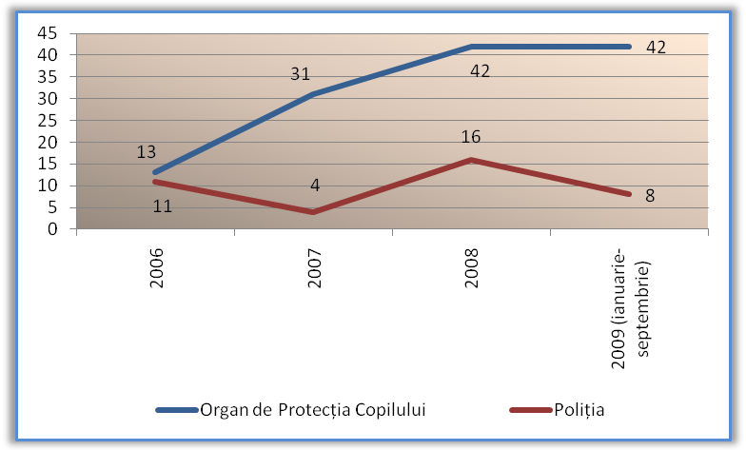
Figure 1. Number of requests for assistance from the law enforcement structures received by the Center for Psychological and Social Assistance”Amicul”.

Figure. 2. Number of requests for assistance from different sources received by the Center for Psychological and Social Assistance ”Amicul” in 2006-2009.

4) Another essential element of good practices, presented in this document, that changed not only the activity of “Amicul” center, but also state policy on child protection in criminal proceedings, was the installation in 2007 with assistance from Oak Foundation of an internal video surveillance system within Center for Psychological and Social Assistance ”Amicul”. . This allowed organizing within „Amicul” center 14 legal interviews of children as part of the preliminary investigation and 2 interviews as part of court examination. Trained psychologists from „Amicul” center provide assistance to criminal investigation officers and prosecutors in organizing legal interviews within police offices and prosecutor’s offices. Thus, only in 2008-2009 30 such interviews were organized.
When children are involved in criminal and administrative cases as victims or witnesses, the specialists from „Amicul” center not only participate in the legal interview of children, but also perform psychological preparation of the child for the interview. The psychological preparation of the child for the legal interview is being performed from 2007, including using the book „I am going to Court” (Maria Keller-Hamela), which was translated from Polish to the state language of the Republic of Moldova and is widely used in the work with children.

5) The fact that psychologists from NCCAP are more often invited to participate in criminal proceedings as specialists or witnesses and more often law enforcement structures ask for written testimonies of specialists psychologists in form of psychological opinions is also a positive sign.
NCCAP specialists write psychological opinions based on an official request from one or another organization and based on a thorough assessment of psychological particularities of the child, of people surrounding him and his living conditions. The increasing quantity of requests for psychological opinions of specialists from “Amicul” center, are proof of the increasing trust of specialists from different state and private organizations in psychological evaluation and psychological opinions.

Table 1. Number of psychological evaluation reports developed by the specialists from „Amicul” center.
Recipient | 2005 | 2006 | 2007 | 2008 | 2009 (January--September)
Prosecutor’s office | 1 | 6 | 3 | 9 | 3
Temporary placement center | 2 | - | - | - | 5
Court | 1 | - | 1 | 1 | 1
Police department | 1 | 4 | 4 | 6 | 2
Child Protection Department / Guardianship authority | - | 3 | 7 | 6 | 7
Attorney office | - | - | 2 | - | 1
Ministry of Social Protection, Child and Family | - | - | - | - | 1
Total | 5 | 13 | 17 | 22 | 20
Total | 77

Conclusions:

The analysis of problems related to the organization of legal interviews of children victims of abuse and witnesses allows for the conclusion that significant changes occurred in this respect on all levels of the child protection system:

- provisions related to the establishment of special rooms for interviews of children included in the National Action Plan;
- targeted training of specialists (prosecutors, police officers, teachers) and provision of materials to increase the effectiveness of interviews;
- increasing of the importance and the role of psychologists in criminal proceedings, including by means of increasing the technical potential of the Center for Psychological and Social Assistance of Children and Families «Amicul».

